Documentation Website

Rick and Morty

Index

Desktop Version

Main page……………………………….…….2

Filter Buttons………………………..……....3

Container of characters………………….4

Phone Version

Main page……………………………….…….5

Filter Buttons………………………..……....6

Container of characters………………….7

Button to scroll up of page……………..8

Main page – Desktop Version

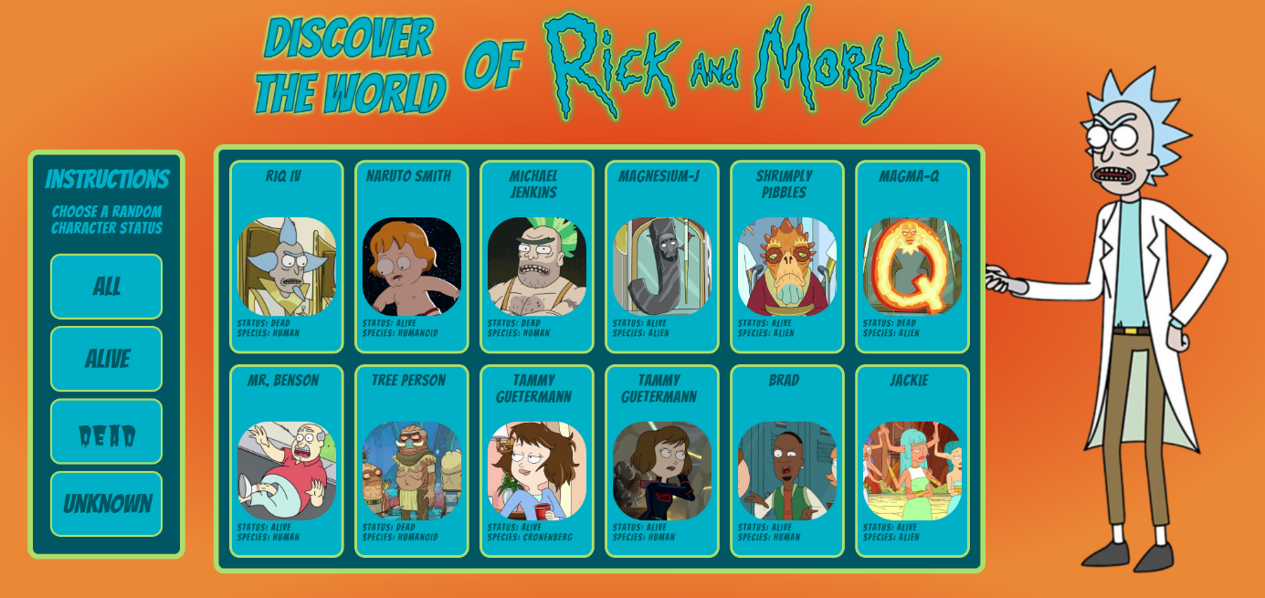

Welcome on the website to discover the world of Rick and Morty.

Here you will find a characters generator which allows you to have information such as name, photo, origin, species, dead or alive, etc…

Filter buttons

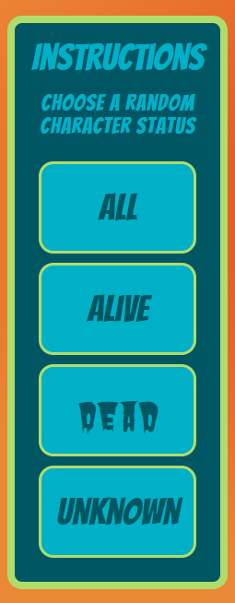

Here you have the buttons which allow you to randomly generate characters: all, alive, dead or unknown.

Container of Characters

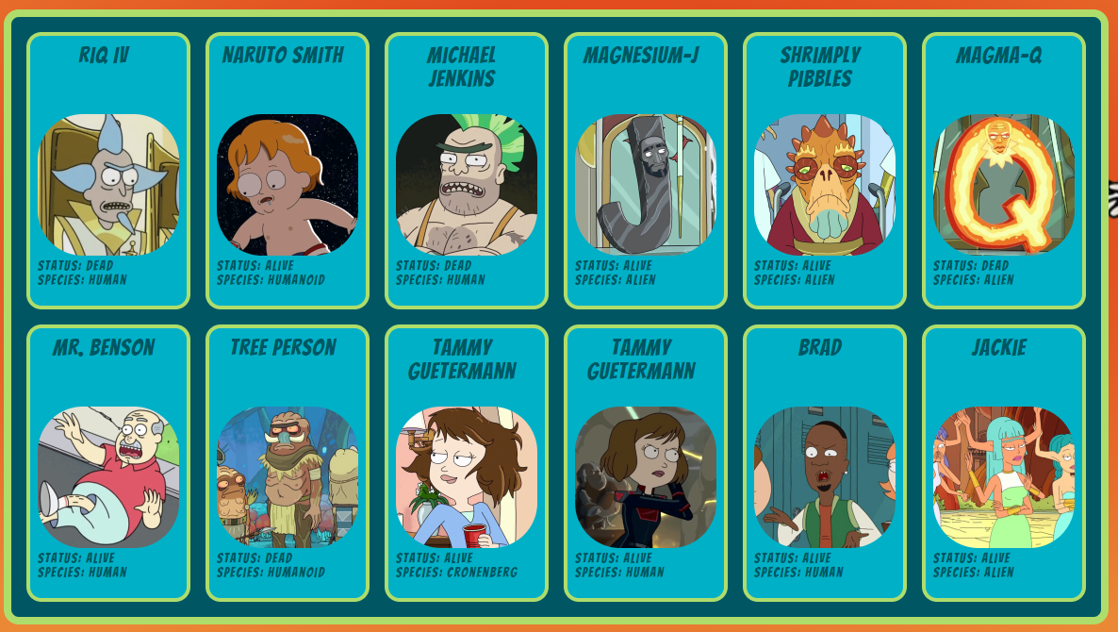

Here are displayed the 12 characters that are generated.

Main page – Phone Version

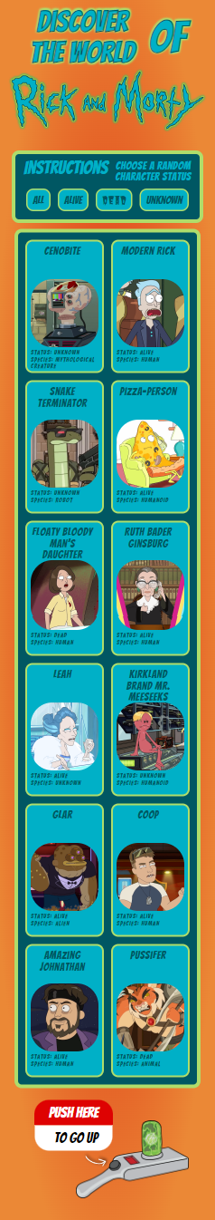

Filter buttons



Here you have the buttons for phone which allow you to randomly generate characters: all, alive, dead or unknown.

Container of Characters



Here are displayed the 12 characters that are generated phone version.

Button to scroll up of page



This button allows you to return to the top of the page in one click.